Work Ready Skills Include Job Health and Safety Skills

The ability to identify, understand, problem-solve, and effectively address workplace health and safety hazards are critical life skills. All high school students need these skills now and in the future. Linked Learning pathways present an obvious and immediate place in California’s education system to teach these skills.

Why these skills are important:

- In 2010, 4,500 workers lost their lives on the job, and another 50,000 died from occupational diseases. That’s a total of 149 workers dying each day. Another 3.1 million were injured or became ill.

- These deaths and injuries impact families, co-workers, employers and the economy.

- Workers under the age of 24 have the highest rate of job injury and are more than twice as likely as older adults to be injured on the job. This means that 795,000 young workers are injured every year, seriously enough to end up in a hospital emergency room. Permanent injuries for youth have a lifelong impact.

- Employees who have the skills to take a proactive, solution-oriented approach to workplace health and safety help create safer, better workplaces, are valued by employers, and can protect themselves and others.

Sheri Sangji, 23, worked as a research assistant in a university lab. She was severely burned over nearly half of her body when air-sensitive chemicals burst into flames during an experiment and ignited her clothing. Sangji, who was not wearing a protective lab coat, died 18 days later.

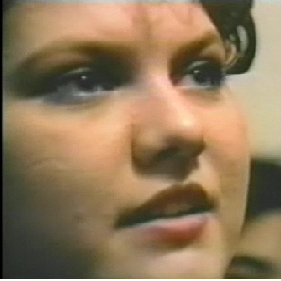

Jamie, 17, worked as a dishwasher in a hospital kitchen. One day, as Jamie was lifting three large pans out of the the powerful chemical solution they were soaking in, they slipped out of her hands. The cleaning solution splashed all over the side of her face and got into her right eye. She was blinded in that eye for two weeks.

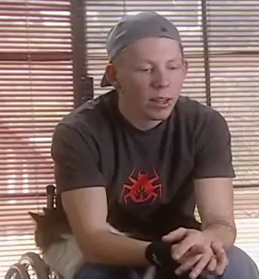

Nick Perry, 19, worked in a lumber yard. When he got off his forklift to adjust a load of plywood, the plywood fell on top of him and broke his back. He is paralyzed from the waist down, and uses a wheel chair.

What skills are needed:

All high school students should be able to:

- Identify key types of health and safety hazards (safety hazards, ergonomic hazards, biological hazards, chemical hazards, other health hazards) in a variety of workplace settings.

- Using systems thinking, explain how workplace hazards are most effectively eliminated or controlled, applying their understanding of the “hierarchy of controls” to specific workplace problems (solutions that eliminate the hazard through engineering or other workplace changes, workplace procedures or safety rules, and, if needed, personal protective equipment).

- Address workplace health and safety problems, using their understanding of employers’ and employees’ rights and responsibilities, knowledge of resources and strategies for seeking help, and skills in effectively communicating with employers and others to solve problems.

21st Century Skills: These health and safety skills dovetail in particular with many of the recognized 21st Century Learning and Innovation Skills:
- Creativity and Innovation: Think creatively; Work creatively with others
- Critical Thinking and Problem Solving: Use Systems thinking; Solve Problems
- Communication and Collaboration: Communicate clearly; Collaborate with others

How to integrate these skills into educational programs:

- Ready-to-use curriculum. Youth @ Work: Talking Safety. Endorsed by the U.S. Dept. of Education’s Career Cluster Initiative, Job Corps, and Skills USA and evaluated in 10 states by the CDC’s National Institute for Occupational Safety and Health (NIOSH). Uses small group activities, role plays, games and other skill-building activities (http://www.cdc.gov/niosh/talkingsafety/). For new revised draft curriculum, with updated illustrations, email dbush@berkeley.edu.

- Free training for teachers and/or work-based learning coordinators. A 3-4 hour training of trainers (TOT) workshop, including the Youth @ Work: Talking Safety curriculum in binders for TOT participants, and CDs with curriculum contents for additional printing at district/school level. Workshop length and content can be tailored to your needs.

- Technical Assistance from UC Berkeley occupational health educators to help teachers integrate these objectives/standards into Linked Learning Projects/Project-Based Learning, or other school- or work-based learning activities (such as ideas for industry experts/speakers related to occupational health and safety).

Contact: Diane Bush, MPH
Young Worker Project Coordinator
Labor Occupational Health Program
UC Berkeley
dbush@berkeley.edu
510-643-2424
www.lohp.org
www.youngworkers.org

